

Conference Pricing | How to Book
RSN Members £235*  Non Members £285*  * All prices stated are exclusive of VAT | - Complete and return the booking form below  - Book a place online here  (Please note online booking fees apply and the new Councillor rate is not available online)  Please return or email completed forms to:  Post:  Rural Services Network, Kilworthy Park, Tavistock,  PL19 0BZ  Email: events@sparse.gov.uk  If you need any further assistance please call us on 01822 851370  CLOSING DATE FOR REGISTRATIONS: 28th August 2017

Conference Agenda

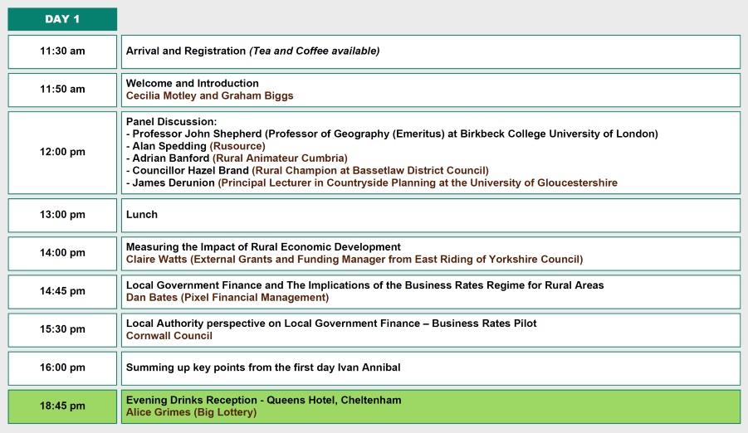

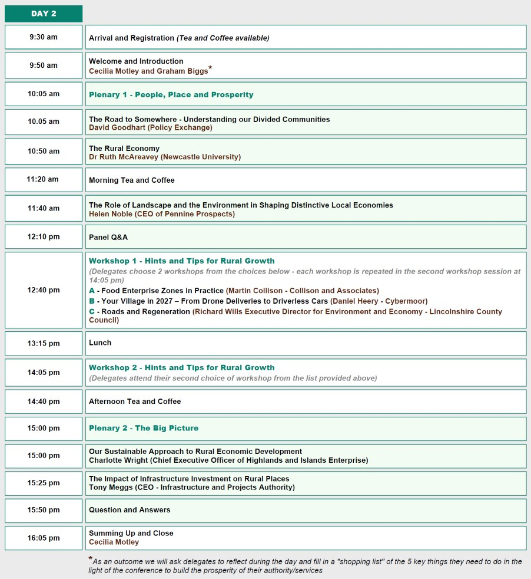

The Infrastructure of Success - New Routes to Economic Growth
Tuesday 5th and Wednesday 6th September 2017

DELEGATE BOOKING FORM

Delegate Details
Please Circle | Mr Mrs Miss Ms Other
Name
Surname
Job Title
Organisation
Address
Postcode
Telephone Number
Email
Workshop Choices (Please indicate your workshop choices below using the corresponding letter as shown in the programme above)
Choice
Workshop Session One
Workshop Session Two
Spaces at workshops may be limited and we will try to assign you to your first choice where possible

Payment can be made by:
Cheque made payable to: Rural Services Partnership Ltd and addressed to: G Biggs, PO Box 101, Craven Arms, SY7 7AL
BACS: Account Name: The Rural Services Partnership Ltd; Sort Code: 30 65 93; Account Number: 14877960
Please quote the invoice number on payment or send a BACS remittance advice to graham.biggs@sparse.gov.uk
Book and pay online: Visit click here (Please note PayPal fees apply)
Payment by invoice:
Name:
Organisation:
Address:
Postcode:

Purchase Order Number: (if applicable)

Do you have any dietary requirements?

Do you have any other special requirements or
access needs?
1 RSN Member Rate *£235.00 2 Non RSN Member Rate *£285.00

Please indicate which conference fee applies to your booking using the corresponding number
* These prices are excluding VAT.
Prices including VAT are: 1 - £282.00 2 - £342.00

Do you require a VAT receipt? (Delete as appropriate)
Yes | No
Confirmation of Booking: All places will be confirmed by email, pending availability.
Please contact us if you do not receive any confirmation 10 days after submitting your booking.

The Rural Services Network
All enquiries to: Rural Services Network – 01822 851370 events@sparse.gov.uk
Please complete and return form to:
Post: Nicola Busuttil, Rural Services Network, Kilworthy Park, Tavistock, PL19 0BZ
Email: events@sparse.gov.uk

CLOSING DATE FOR REGISTRATIONS: 28th AUGUST 2017

RSN is the national champion for rural services, ensuring that people in rural areas have a strong voice. We are fighting for a fair deal for rural communities to maintain their social and economic viability for the benefit of the nation as a whole.

The Rural Service Network:
- Makes representations on issues affecting rural services
- Promotes active networking between service providers and across all sectors
- Establishes and broadcasts rural best practice
- Promotes debate and interaction between agencies/sectors across many areas of joint interest for example rural crime, rural housing, broadband provision and rural health

The Network comprises over 150 Local Authorities (SPARSE Rural and Rural Assembly) and around 100 Non Local Authority Service Bodies (Rural Services Partnership Ltd) and has Affiliate (Private Sector) Groups. Adequate recognition of the additional cost of provision of rural services in the countryside is an important issue for the Network. The Network was instrumental in the formation of the All Party Parliamentary Group on Rural Services in Parliament. It involves 66 Parliamentarians.

The Network is believed to be unique in Europe and seeks to foster constructive debate on all English rural service issues. Its weekly email newsletter on rural news and comment goes out to some 45,000 people in service and consumer groups. At grass roots level, we have a Community Group comprising 4,000 Local Councils, 3,000 Schools and 500 other rural organisations. “Calls for Evidence” and questionnaires seek to provide operating experience, best practice and collective rural viewpoints.

This information is disseminated and available through our widely respected website (www.rsnonline.org.uk). The group provides services through membership subscription and contract revenue and does not receive any Government grant.

All enquiries to: Rural Services Network - 01822 851370
Please complete and return form to:
- Post: Nicola Busuttil, c/o Rural Services Network, Kilworthy Park, Drake Road, Tavistock, PL19 0BZ
- Email: events@sparse.gov.uk
CLOSING DATE FOR REGISTRATIONS: 28th August 2017

