Dorset Housing Profile


The RSN Housing Profile brings together key data to inform and contextualise a local authority areas housing situation. The analysis provides comparison to the average for the authority class and for the rural classification of the local authority. The sheets are editable to allow narrative descriptions and to emphasize or delete the graphs as may be appropriate for the intended use and for your local authority area.
The areas covered are:
- House building
- Additions to housing stock
- Housing and accommodation affordability
- Private rental affordability
- Homelessness and Temporary Accommodation

House building

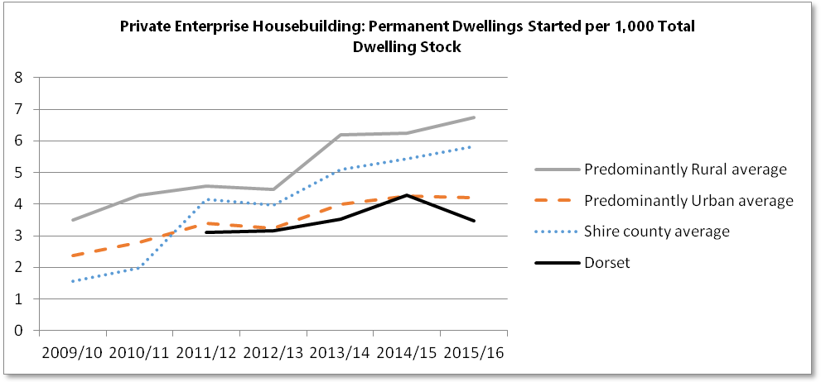
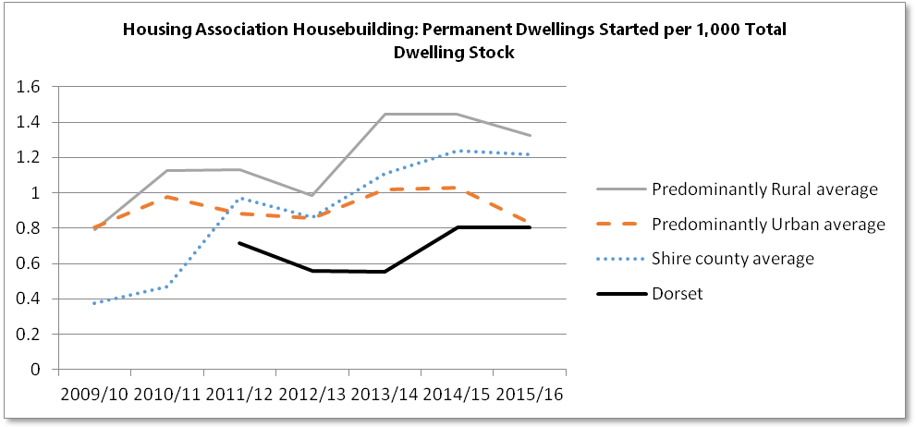
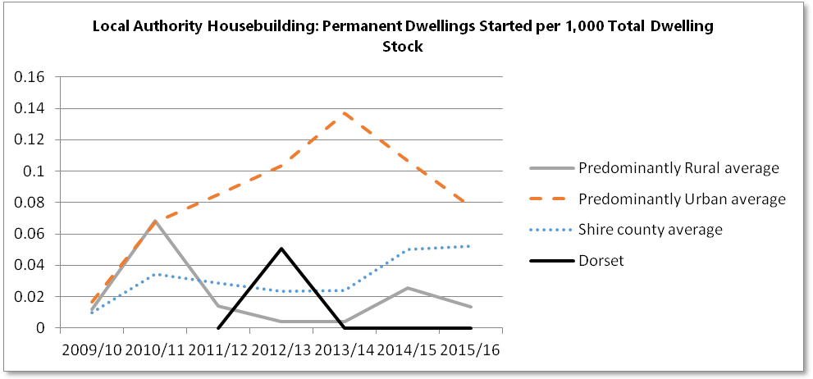
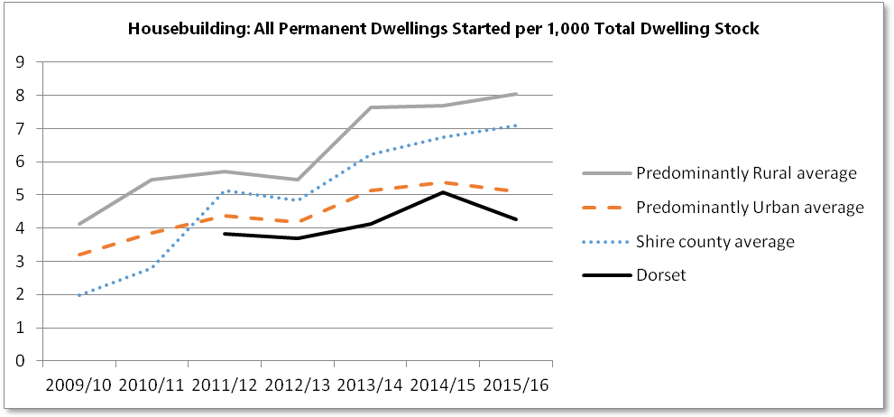
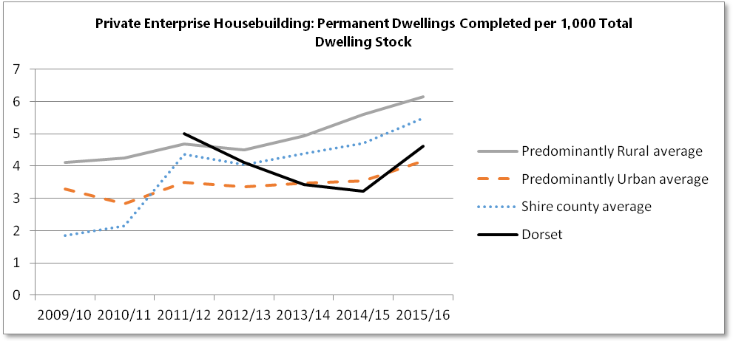
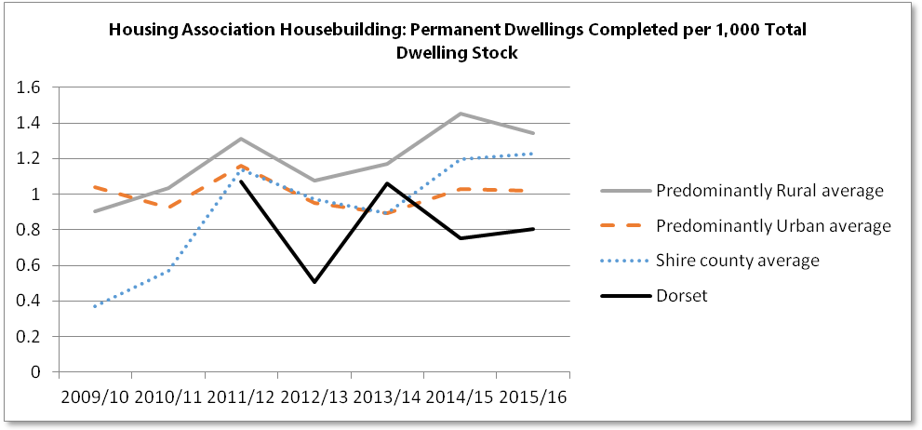
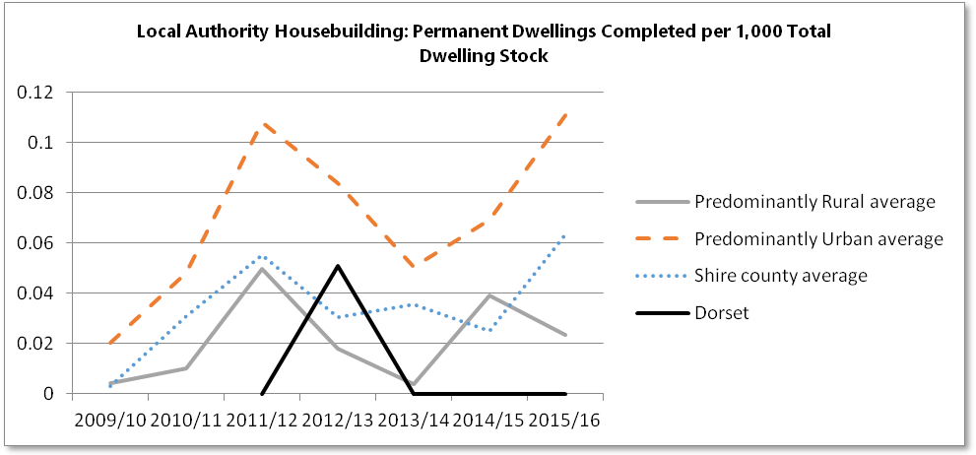
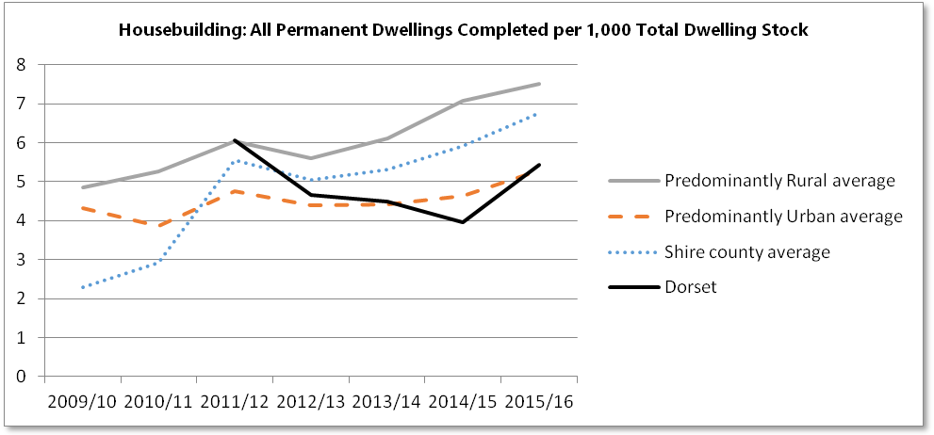

Overall housebuilding (starts and completions) as a proportion of dwelling stock has generally increased since 2009/10. This total rate of housebuilding has been greatest in Predominantly Rural authority areas, however this is not reflected by local authority housebuilding where the rate of local authority builds is greatest for Predominantly Urban local authorities. Private enterprise housebuilding provides the greatest proportion of builds for both rural and urban areas.
Dorset in 2015/16 saw total completions of 1,080, made up of 920 private enterprise builds and 160 housing association builds. This was on a total dwelling stock in 2015 of 199,030.

Additions to housing stock

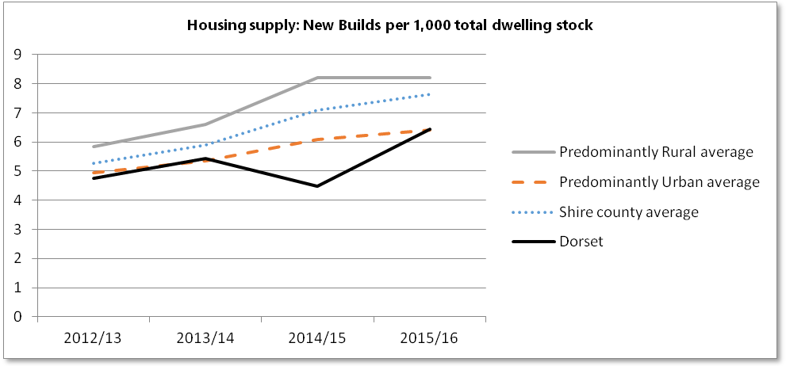

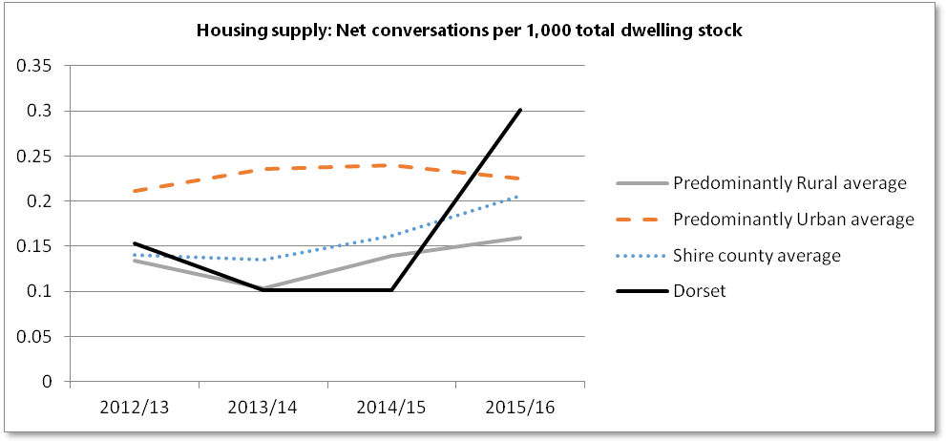

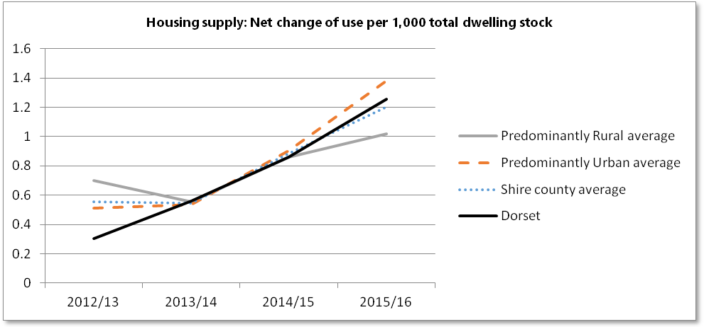

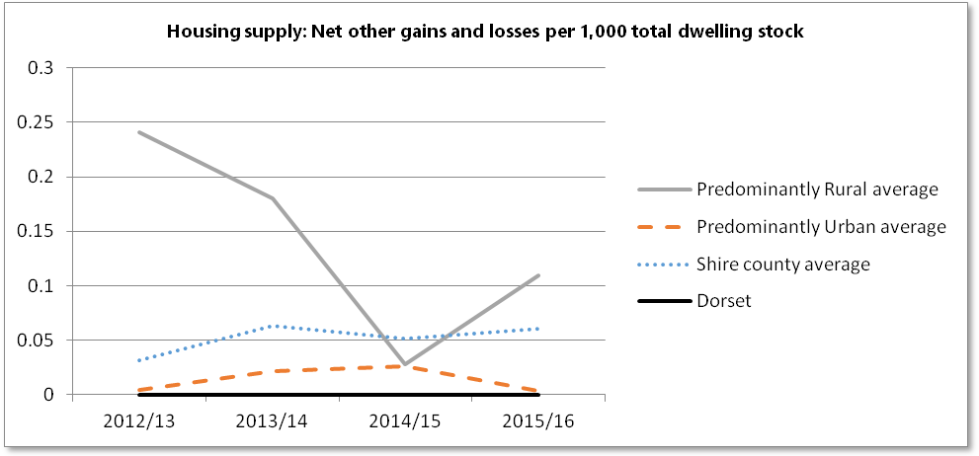

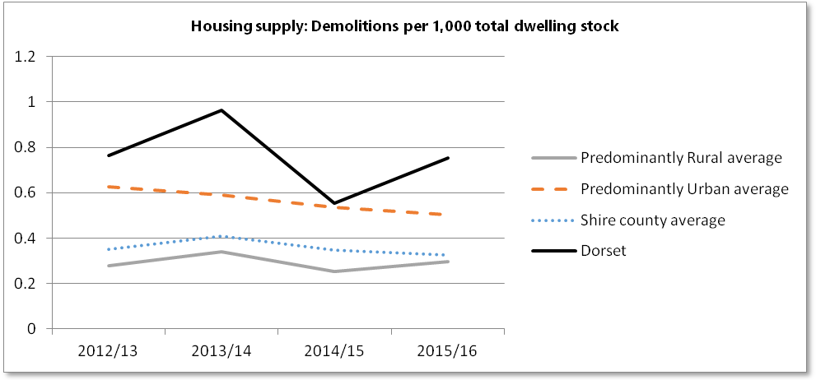

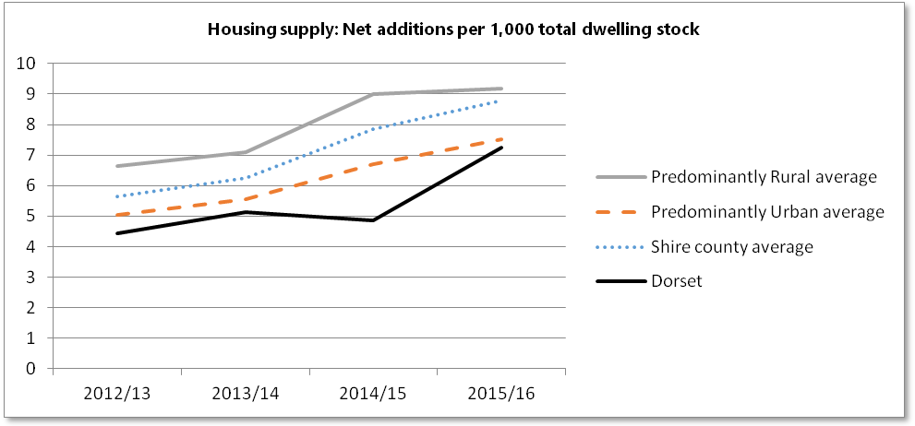

In England most housing supply comes from new builds, and this is greatest for Predominantly Rural areas. As might be expected the rate of demolitions and conversations is greatest in Predominantly Urban areas.
For 2015-16 Dorset had net additions of 1,440 dwellings comprised of 1,280 new builds, 60 conversations, 250 change of use, and 150 demolitions (the remaining being 'net other gains and losses').

Housing and accommodation affordability

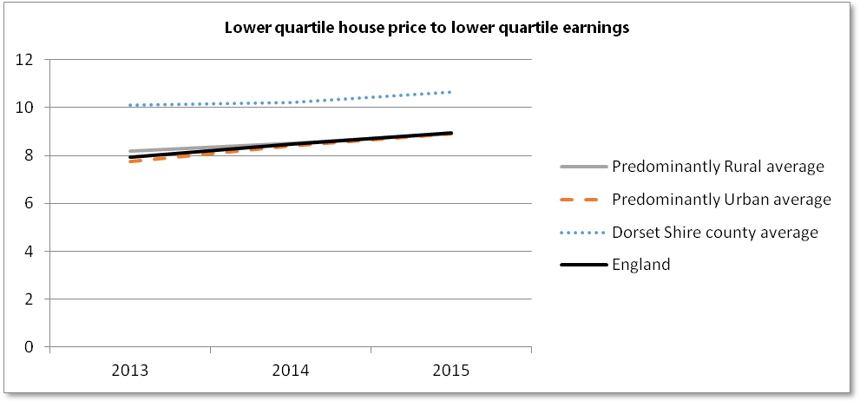

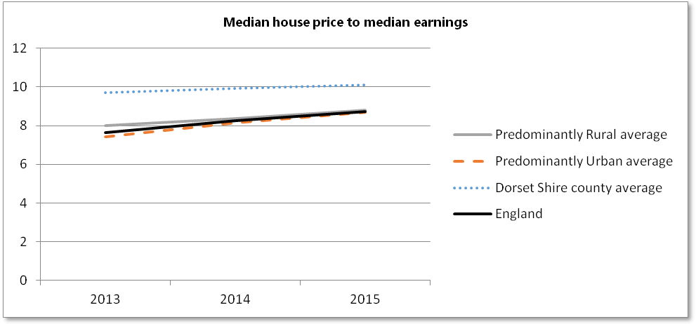

Access to affordable housing is a continuing issue and although the gap in the ratio of house price to earnings has reduced in recent years, housing continues to be less affordable in rural areas.

Private rental affordability

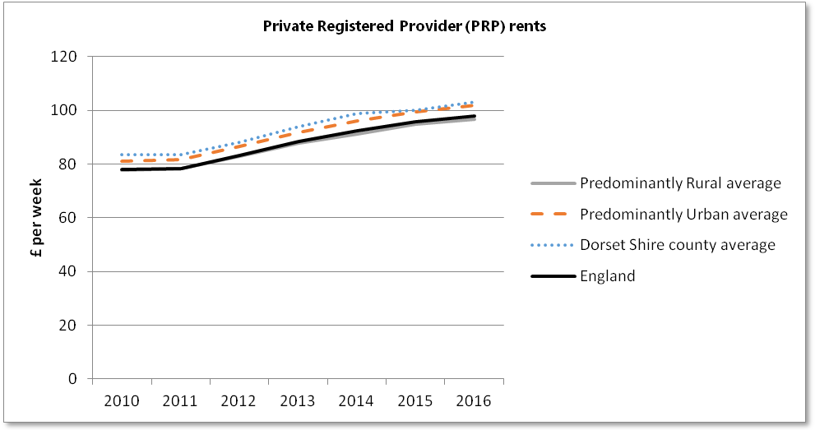

Private registered provider rents are similar between Predominantly Rural and Predominantly Urban areas and are lower in Predominantly Urban areas if London is excluded. Earnings for individuals who work or live in urban areas are generally slightly higher than for individuals who work or live in rural areas, which may result in lower affordability in rural areas.

Homelessness and Temporary Accommodation

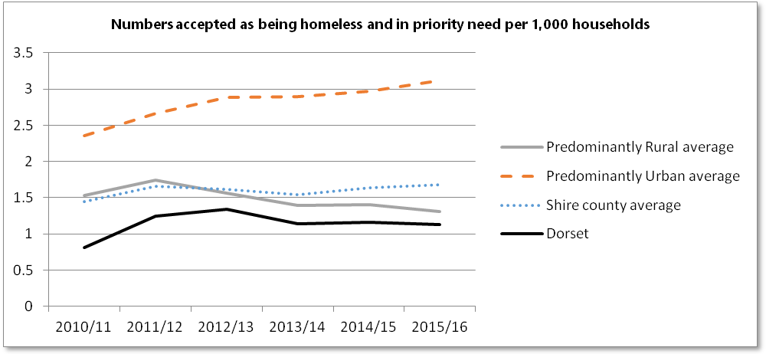

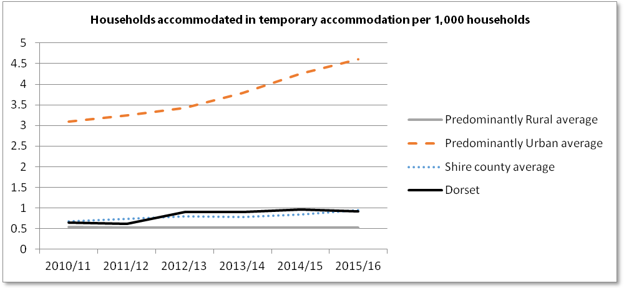

In Dorset in 2015/16 the number accepted as homeless and in priority need per 1,000 households was 1.1, the number of households accommodated in temporary accommodation per 1,000 households was 0.9.

Statistical sources

DCLG Housebuilding Statistics - Table 253 Housebuilding
DCLG Housebuilding Statistics - Table 123 Housing Supply
DCLG Housing and Planning Analysis - Tables 576 & 577 Housing Affordability Ratios
DCLG Housing Statistics - Table 704 Private Registered Provider (PRP) rents
DCLG Homelessness Statistics - Table 784 Local Authorities' Action Under The Homelessness Provisions of the 1985 and 1996 Housing Acts
DCLG Housing Statistics - Table 100 Dwelling Stock

