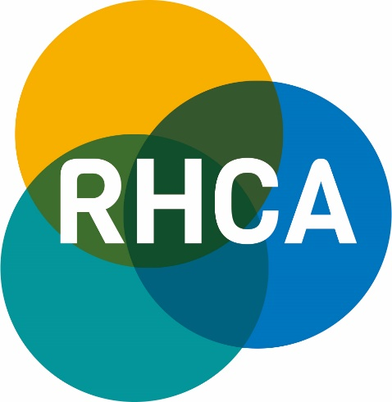

MEMBERSHIP OF THE RURAL HEALTH AND CARE ALLIANCE

Dedicated to getting a fair deal for
Rural communities in terms of health and care

ORGANISATION DETAILS
Name of Organisation
INDIVIDUAL DETAILS
Please provide details for the main contact
Please Circle | Mr Mrs Miss Ms Other
Name
Surname
Job Title
Organisation
Address
Postcode
Telephone Number
Email
Signature

Date

As a new member of RHCA, please find a link to the website: www.rsnonline.org.uk then click on the link
at the top of the home page to the RHCA page. There is a specific area which will detail the work and the
involvement of our Members.
Please could you provide the following?
1 Logo: A jpeg or png version of your organisation’s logo
2 Website: Four or five paragraphs on the work of your organisation but with one or two of them setting out your particular
concerns and challenges from a rural perspective
3 Contacts: A list of up to 20 members of your organisation who have an interest in rural health who you believe will benefit
from receiving information from us directly. (Please see last page of membership form)

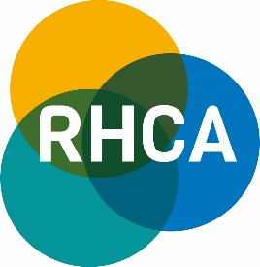

INVOICE DETAILS
Please provide details for invoicing
Please Circle | Mr Mrs Miss Ms Other
Name
Surname
Job Title
Organisation
Address
Postcode
Telephone Number
Email
Purchase Order No
(If applicable)

Payment options:
1 Cheque made payable to: Rural Services Network and addressed to: G Biggs, PO Box 101, Craven Arms, SY7 7AL
Please write the Organisation or invoice number on the back of the cheque.

2 BACS: Account Name: The Rural Services Network: Sort Code: 30-65-93; Account Number: 14877960
Please quote the invoice number on payment or send a BACS remittance advice to graham.biggs@sparse.gov.uk

Yes | No
Do you require a VAT receipt? (Delete as appropriate)

General Data Protection Regulations
Under the the General Data Protection Regulations, we process certain details under the basis of a Legal Contract. Our services are delivered predominantly through electronic means. If we did not maintain details of our membership, we would not be able to fulfil the terms of the contract that we hold with you.
These details are not shared with any other customers or contacts, other than the National Centre of Rural Health and Care, the Rural Health and Care Alliance and the Rural Services Partnership and are maintained solely for the purposes of fulfilling the contract requirements.

In addition to our databases, these details are also maintained in a third party software system, provided by Mailchimp. Every electronic newsletter contains a link for the organisation to unsubscribe from the list that we maintain and clearly states who it is from and the contact details of our organisation.

Please tick the box to confirm that, on becoming a member of the RHCA, you agree to being contacted by us and that we can send you information regarding your membership and any other RHCA related matters.

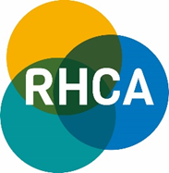

CONTACT LIST
Please provide name, job title and email address for each contact
1
2
3
4
5
6
7
8
9
10
11
12
13
14
15
16
17
18
19
20

Please complete and return membership form to:
Post: Rural Services Network, Kilworthy Park, Tavistock, PL19 0BZ or
Email: Nadine.Trout@sparse.gov.uk
Tel: 01822 851 370

