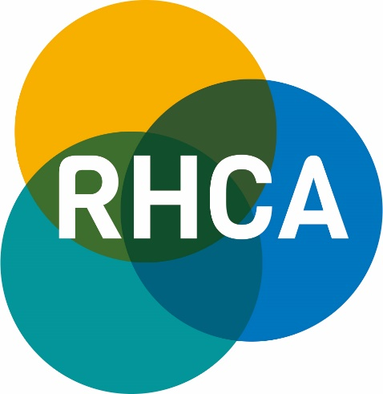

MEMBERSHIP OF THE RURAL HEALTH AND CARE ALLIANCE

Dedicated to getting a fair deal for
Rural communities in terms of health and care

Please provide details for the main contact
Please Circle
Name
Surname
Job Title
Organisation
Address
Postcode
Telephone Number
Email
Signature

Date
Purchase order number if applicable

As a new member of RHCA and Rural Services Partnership Ltd, please find a link to the website: www.rsnonline.org.uk then click on the link at the top of the home page to the RHCA page. There is a specific area which will detail the work and the involvement of our Members.
Payment options:
1 Cheque made payable to: Rural Services Network and addressed to: G Biggs, PO Box 101, Craven Arms, SY7 7AL
Please write the Organisation or invoice number on the back of the cheque.

2 BACS: Account Name: The Rural Services Network: Sort Code: 30-65-93; Account Number: 14877960
Please quote the invoice number on payment or send a BACS remittance advice to graham.biggs@sparse.gov.uk

Yes | No
Do you require a VAT receipt? (Delete as appropriate)
Notice period
Please note that after year one, as a member it will be necessary to give twelve months’ notice, in writing, that you wish to withdraw. You will be required to pay your membership contribution in the financial year that you have given notice and the period up to the date of resignation.

General Data Protection Regulations
Under the the General Data Protection Regulations, we process certain details under the basis of a Legal Contract. Our services are delivered predominantly through electronic means. If we did not maintain details of our membership, we would not be able to fulfil the terms of the contract that we hold with you.
These details are not shared with any other customers or contacts, other than the National Centre of Rural Health and Care, the Rural Health and Care Alliance and the Rural Services Partnership and are maintained solely for the purposes of fulfilling the contract requirements.

In addition to our databases, these details are also maintained in a third party software system, provided by Mailchimp. Every electronic newsletter contains a link for the organisation to unsubscribe from the list that we maintain and clearly states who it is from and the contact details of our organisation.

Please tick the box to confirm that, on becoming a member of the RHCA, you agree to being contacted by us and that we can send you information regarding your membership and any other RHCA and RSP related matters.

CONTACT LIST
Please provide name, job title and email address for each contact.
1
2
3
4
5
6
7
8
9
10
11
12
13
14
15
16
17
18
19
20
Please complete and return membership form to:
Email: nadine.trout@sparse.gov.uk
Tel: 01752 686 641

