PRIVATE SECTOR PANEL AND PATRON

This report seeks to explore a potentially large step forward for the organisation as we seek to solidify and direct the 'sponsorship' arrangements.

We seek through this report to introduce a number of new aspects to the network to facilitate this:

(a) the introduction of a formal private sector panel

(b) the concept of a patron

(c) the introduction of specific areas of support from members of the proposed panel allowing support, strengthening and in some cases widening of the networks activities.

Diagram of the Intended Private Sector Panel

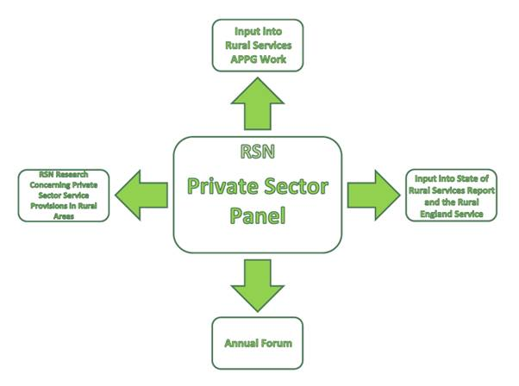
Why is the RSN doing this?
Many rural communities experience poor access to basic services. If anything, evidence shows that rural service decline has been faster among private providers than among public providers e.g. pubs, shops, petrol stations. This is because of widespread market failure in rural areas. Private providers are also key to some of the most intractable rural services issues, such as broadband provision and tackling fuel poverty.

Private providers deliver many so-called ‘public services’, on a contractual or commissioned basis. This is set to grow. Government policy is to open up service provision to more private (and community/social enterprise) sector providers, with public authorities stepping back into strategic and commissioning roles. It is also noted that it is the private sector (including private service providers) that the Government is now looking to deliver economic growth. The Government’s Growth Review has highlighted the contribution it is seeking from rural economies.

It is suggested we now establish a RSN Private Sector Panel.

Suggested Mission Statement for a Panel

- to seek to strengthen, support and improve the operation of services to meet the needs of rural communities in England

What would be the Panel’s direct functions?
- The opportunity to input into the Annual State of Rural Public Services report, so that issues such as ‘open public services’, commissioning and cross-sector working are better encapsulated by it;
- A chance to input to the Rural Services APPG, so that it can better consider the private sector dimension to its considerations. The scope of the APPG would thereby be enlarged to consider the provision of shops, pubs, telecoms, utilities, etc and not just from a community or social enterprise perspective.
- To steer some specific (new) RSN research on opportunities for and issues concerning private service provision in rural areas.
- To assist generally with the RSN's Rural England Service (See below diagram)
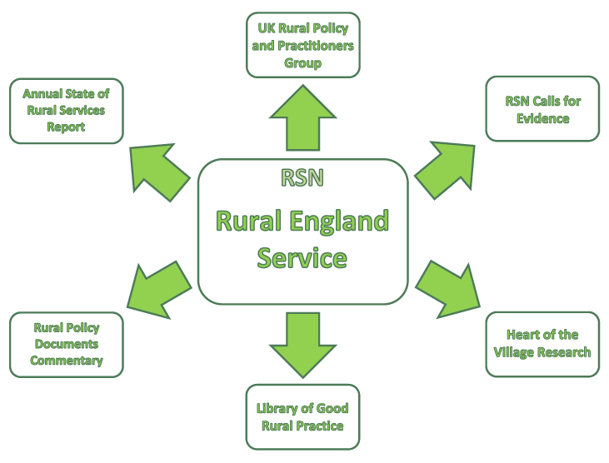
- To inform rural service thinking ensuring that the private sector service provider viewpoint is strongly represented in the work of the Network
- To introduce both collectively through the panel and through its individual members' briefs some new services into the RSN as a whole
The panel members would benefit through:-
- Public and acknowledged association with the aims and ambitions of the RSN and its work (Corporate Social Responsibility);
- Representation – opportunities to raise their issues and concerns with other rural service providers and where appropriate then raised with National and local policy makers, regulators and service commissioners
- Free access to RSN activities e.g. consultations, calls for evidence and products e.g. good practice material;
- Opportunities to network with local authority and other statutory providers in RSN membership.
- Promotion – a chance to be seen as a Rural Business Champion in material that goes out to thousands of rural community representatives who are in our membership.
- Development – opportunities to take part in member activities, such as the seminars and the Rural Services All Party Parliamentary Group hearings.

How would the Group operate?

The panel will it is suggested have two meetings a year
This will be supplemented by two e mail conference sessions

What sectors could be represented?

The Panel will hopefully be around 15 to 20 organisations. It will be broadly representative of those sectors delivering services to rural communities (not just any private sector business) seeking to include those with a particular interest in reaching rural markets. The sectors will it is suggested include a:-

- Retail Firm-one with a clear rural empathy
- Telecoms e.g. a provider of local Wi-Fi broadband networks;
- Pubs e.g. a rural brewer or smaller pub chain owner;
- Transport Provider e.g. a bus operator; (First Group)
- Transport User--A Transport Users Group*;
- Utility Provider e.g. an electricity or a water company;
- Social care or health provider – one operating in some predominantly rural areas;
- Petrol retailer e.g. one of the chains with small stations in rural areas;
- Refuse collection/waste management e.g. a company provider active in predominantly rural areas;
- Estate and land estate agent i.e. a company with a strong rural profile ;
- Fuel Supplier; particularly one with a clear rural identity; (Calor)
- Planning Consultancy Firm; a number of firms specialise in rural areas;
Whilst it is probably not possible to find rural 'specialists' in all fields it is suggested we also seek representation from a:-
- Bank or Insurance Firm operating in rural areas;
- Consumer Protection Group*
- The Post Office*
- Social Enterprise Foundation*
- Housing Provider
- Safety Equipment Provider
- Road Engineering Firm
Hopefully the more commercial organisations could be persuaded to contribute a sum in the region of £8,000 to £10,000. For the less commercial (marked here with an asterisk) their input may be financially non contributory although it is hoped they would become members of the RSP.
What business or who might champion it?

The group it is suggested would be chaired by an overall network patron.

The Network Patron
As opposed to the Network writing out to firms seeking sponsorship as we have done to date we suggest we focus our efforts here around a patron. Hopefully this might be a person with a reasonably high public profile who would then in turn write out to suitable firms looking to establish a panel into which our existing sponsors ( e.g. First Group and Calor could be incorporated).

What then should be the role of a Network Patron??

The following are suggested:-

~To be a figurehead fronting particular areas of the Network's activities

~To be particularly involved with the Network's Rural England Service

~To emphasise areas of the RSN's work away from the representational role

~To provide a strong media profile to provide general areas of work with clear identity and drive.

~To chair the Network's Private Sector Panel.

( the position relating to the RSN Chair, Vice Chairs and Executive (who tend to be associated perhaps towards public service provision) would it is intended be unaffected by this)
THE PANEL
Although we would seek to achieve a contribution of around 8- 10k from each of the 'commercial' organisations being approached in seeking each of these representatives there should it is suggested be a clear purpose for involvement in the networks activities. Instead of a straight request for money/involvement approaches might therefore in some cases be made in the context of a defined area of improvement and lean perhaps towards grant application seeking short term objectives. The approach would always be to underpin and in some areas expand RSN services.
It is felt the following a number of common goals should be established from all those who would become involved:-
- Library of Good Rural Practice (expansion)
- Expansion of the e community network to allow us to consult the full rural cross section when we need to. At the moment we have a community section dictated by membership. There are occasions when it is good to establish a view across all rural authorities and on those (rare) occasions it would give the RSN profile with non members.
- State of the Rural Services Report expansion to take in private sector considerations
- Financing a PhD student looking at rural service issues.
- Expanding the APPG to allow it to give more consideration to private sector rural service input
- A small quarterly community grant scheme of 3k every 3 months together with the continuation of a rural grant assistance service.
It is recommended the following 'specific' briefs should relate to involvement from individual service providers:-
- Retail a supermarket or one of the village convenience store chains.
UK Policy and Practitioners Group Expanded Operation. The aspiration would be to extend this group to local authorities and interested organisations from across the 4 Home Countries.
Possible introduction of a wiki link . Such links works well in other organisations giving member organisations the opportunity of online dialogue.
- Bank. Serving rural areas.
Outreach Service Studies
- Rural Pub Chain
Calls for Evidence (plus analysis/ short report) among the community groups?
(Public House Statistics)
- Telecoms e.g. a provider of local WiFi broadband networks;
Broadband Advisory Service
It would be very good to be able to offer a dedicated commentary in this vital area.
- Transport e.g. a bus operator. (First Group Buses;)
Academic research on rural transport issues?
- Fuel Supplier. (Calor)
Fuel Poverty Advisory Service
Fuel Poverty Best Practice Pages
As with broadband special focus here would be extremely useful
- Other utilities e.g. a water or electricity company;

Library of Rural Opinions
A further valuable service could be developed by pooling relevant work carried out by member authorities. This is a simple idea developed that takes the view that the IP (intellectual property) generated within the public sector is an unrealised asset that should be seen as an opportunity, a way to reduce duplication, and a revenue and efficiency generator.

What could happen if the IP accrued by public sector spending was, by default, assigned to a not for profit foundation? If the resulting IP was classified, categorised and made publicly available then all sorts of possibilities start to emerge.

First, significant duplication of spending could be avoided and cost efficiencies gained. If, as part of all procurement practice, a search was made of an IP register, duplicates and close matches to the desired procurement could be easily identified. Instead of re-commissioning the same product or service public money would be saved. The same search would also be able to identify suppliers who had direct experience of developing similar products successfully, and by inviting experienced suppliers to tender significantly improving the quality and competiveness of the tender pool.

Making the data available publicly would also allow entrepreneurs and social enterprises to identify and develop opportunities which, through a form of licensing system, would allow the foundation to be sustainable and allow member authorities to generate additional revenues by having a share of the licence.

The foundation would be easy to set up. The software requirements are fairly simple and no significant effort is needed by the public sector. This proposed service has potential value across all parts of the public sector but could be piloted initially either in relation to rural economic development and/or in relation to a pilot region.

This would be a really useful service
- Social care or health provider – one operating in some predominantly rural areas;
(1) Annual Rural Health Conference
To be able to offer an annual health event perhaps jointly with the Institute of Rural Health
(2) Rural Health Wiki Link
again possibly in partnership with the Institute of Rural Health.
- Petrol retailer e.g. one of the chains with small stations in rural areas;
A Small Business Index
To allow for survey work.
To be able to incorporate a business consultation arm across member areas.
- Estate and land estate agent – with a major rural interest. Knight Frank
Rural Regional Forums and Seminars
Eight forums and seminars across the regions to follow up on the success of this year’s events.
- Safety Equipment Provider
Rural Crime Conference
If achievable is clearly the way to get a rural crime group up and running.
Rural Fire Service Conference
Again the conference approach would assist in pulling this group together.
- Planning Consultant
Neighbourhood Planning Service
A very topical area where it would be excellent to introduce an initiative at this stage . We suggest special web site pages with links to bodies funded by DCLG to provide advice and to other useful Neighbourhood Planning resources/websites.
- Housing Company
(1) Rural Housing Seminar
It is hoped we can stage rural housing break out sessions at the main annual CIOH conference
(2) Rural Housing Wiki Link

- Waste Management Company
Rural Cost Indicator
An indicator established to measure additional cost falling to rural areas due to the additional distance required to be travelled which is then linked to increases in fuel and other relevant costs.
The indicator may also be able to extend to running costs of the additional building requirement of rural area operation.
- Rural Engineer
Rural Highway Research
~ It is obviously difficult to foresee in any detail but a split of the contribution say of 50/50% between the common goals and the specific briefs might suggest itself as a broad guide.
~Some of the proposals outlined above covers a small proportion of existing expenditure.
CONCLUSION
It is clear that from the subscription viewpoint the organisation is reaching its ceiling in terms of income. Those councils who are currently outside the organisation have been asked to be involved on an infinite number of occasions and they are still not inclined to become involved if this is the case when a beneficial financial carrot through the rural service cost discussion is being dangled in front of them they clearly will not be for turning while their present administrations are in place. Continual approaches seem to be reaching a point of being counterproductive. Progress here is unlikely to occur within the next two years.
The Rural Services Partnership is unlikely to provide additional income in the foreseeable future. Certainly in terms of individual service member growth it is likely we will have proceed with a number of free subscription initiatives and these are detailed separately on this agenda.
It is clearly beneficial in terms of retention if the organisation can provide more from non subscription sources. This report seeks to establish a system capable in theory at least of doing that. If successful (or even half successful) the Network would be very considerably strengthened.
The balance sought however is a fine one. If members detect too heavier private sector influence and financial input they will less inclined to feed in subscription. We are walking a fine tightrope but hopefully this report balances private sector involvement and support in a way that will have very constructive outcomes all round.

